Save 'n' Send to BBO - Lin file upload
Compiled by Roger Pfister http://RogerPf.com/aaBridge

You are in aaBridge and see a hand you want to send to BBO
If you already have the hand(s) as a lin file then see the next page.
The only way to send a deal to BBO is by having it in a lin file.
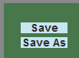
You are viewing a hand in aaBridge. If you are already "inside the deal", great, you will be able to see the Save and Save As buttons.
If instead you can see the 1st , Cont or Enter the Deal you will need to click one of them to "Enter the Deal".
Whenever you try to save a deal using either of those buttons the resulting lin file will, by default, be put in your Saves folder.

To save the deal

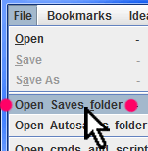
Click Save or Save As and if asked, enter a file name and press the Enter Key.
Look in your Saves folder
Menubar File > Open Saves folder - ... (red dots)
the file may well have a long name (if you did not shorten it) which includes today's date and time.
d__2018-08-14__13-39-27__2N-by-We... .lin
You now have a lin file that you can send to BBO
See the next page.

You already have the deal or deals as a lin file
If you don't, please read the Doc Collection doc
Enter (Type) Hands into aaBridge

You can upload the lin file to a folder on BBO in the normal way.
First login to BBO, go to Hands and Results and create a folder.

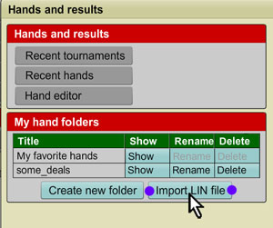
My BBO > Hands and Results > (blue button) Create new folder

For this example of lin file called some_deals.lin I would make a BBO folder called some_deals

Click the (blue button) Import LIN file (a dialog will appear)
Click the Select button for the folder you want to fill.
Click the (white) Choose file button and select the .lin whereever it is on your computer (not shown).

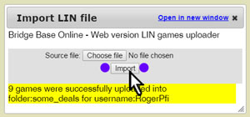
Click the (white) Import button
and you should see that all your deals (games) have been accepted by BBO.

On BBO you can use the uploaded files on a Teaching or Bidding table
To do this the table boss clicks the Deal source (blue button) near the center and then clicks Use saved deals and selects the folder they what to read the deals from.
Or the table boss can put a single deal on a Teaching or Bidding table via
My BBO > Hands and Results, next
Click Show next to the folder of deals you want, next
Click Show next to the board # you want, next
Click “Export deal” near bottom of that panel, and finally
Click “Upload deal to table” from the pop-up menu.
<end document>

